

UNIT CONVERTER APPLICATION (PYTHON)
PROJECT REPORT

Project Title: Unit Converter Application (Python)
Submitted by: Sanskriti Tyagi
Institution: Vellore Institute of Technology Bhopal
Year: 2025

INTRODUCTION

The Unit Converter is a Python-based application designed to convert values across length, weight, and temperature units. It simplifies daily measurement tasks and showcases Python fundamentals including functions, loops, conditionals, and input handling.

PROBLEM STATEMENT

People frequently need to convert measurement units accurately. Manual conversion is error-prone and time-consuming. The objective is to build a simple console-based tool that performs fast and accurate unit conversions.

The problem:
A simple, user-friendly tool is needed to accurately convert values between common units without requiring manual calculation or external formulas.

Goal: To develop a Python-based Unit Converter that covers commonly used unit categories and delivers accurate results instantly.

FUNCTIONAL REQUIREMENTS

- Convert length units (m, cm, km, miles)
- Convert weight units (g, kg, lb)
- Convert temperature units (C, F, K)
- User-friendly interactive menu
- Input validation
- Repeated usage without restarting
- Support conversion for Length (meter, centimeter, kilometer, mile, foot, inch)
- Support conversion for Weight/Mass (gram, kilogram, pound, ounce)
- Support conversion for Temperature (Celsius, Fahrenheit, Kelvin)
- Interactive menu-driven interface
- Bidirectional conversion (e.g., meter ↔ feet)
- Input validation (numeric values only)
- Option to perform multiple conversions without restarting
- Clear display of results with proper unit labels

NON-FUNCTIONAL REQUIREMENTS
- High accuracy
- Fast performance
- Easy maintainability
- User-friendly design
- Portability across systems
-No external dependencies (pure Python)

SYSTEM ARCHITECTURE
Input Layer Conversion Engine Output Layer User inputs data conversion logic processes it results are displayed.

- User Input Module
Accepts value and unit selection. 2
- . Conversion Engine
Applies conversion formulas using Python functions.
- Result Display
Shows converted result.
- Loop Controller
Allows user to repeat operations.

DESIGN DIAGRAMS
USE CASE DIAGRAM:
Use Cases:
• Select category
• Enter value
• Choose unit
• Convert units
• View result
• Exit program
User Select Units Convert View Result
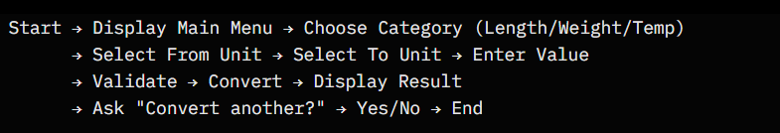

WORKFLOW DIAGRAM:
Start Choose Category Enter Value Convert Show Result Continue End

SEQUENCE DIAGRAM:
User Program Conversion Function Output Result

CLASS DIAGRAM:
UnitConverter convert_length() convert_weight() convert_temperature()

DESIGN DECISIONS & RATIONALE:
Chosen to be console-based for simplicity. Modular functions allow easy expansion. Error handling improves reliability
• Functions were used to group conversion logic, improving code readability.
• If-else statements were used for simple decisionmaking
. • No database was used to keep the system lightweight
. • Loop structure allows continuous use without restarting the program

IMPLEMENTATION DETAILS
Python used with structured functional design. Conversion formulas implemented with accuracy

Core logic uses Python fundamentals:
• Functions for each category
• Dictionary-based unit mapping
• Temperature conversion formulas
• Error handling using try-except
• Input validation for numeric values
Example Code Snippet:
def meter_to_km(m):
return m / 1000
value = float(input("Enter meters: "))
print("Kilometers:", meter_to_km(value))

Screenshots / Results:-
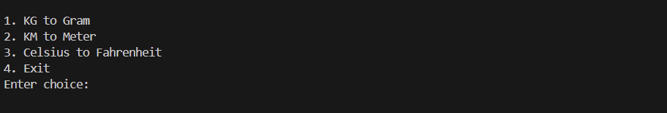
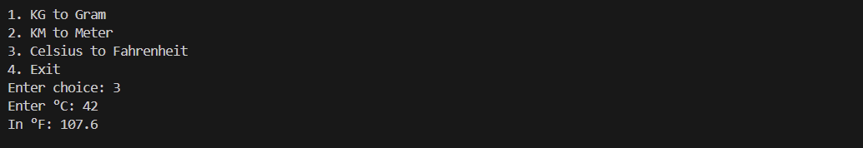
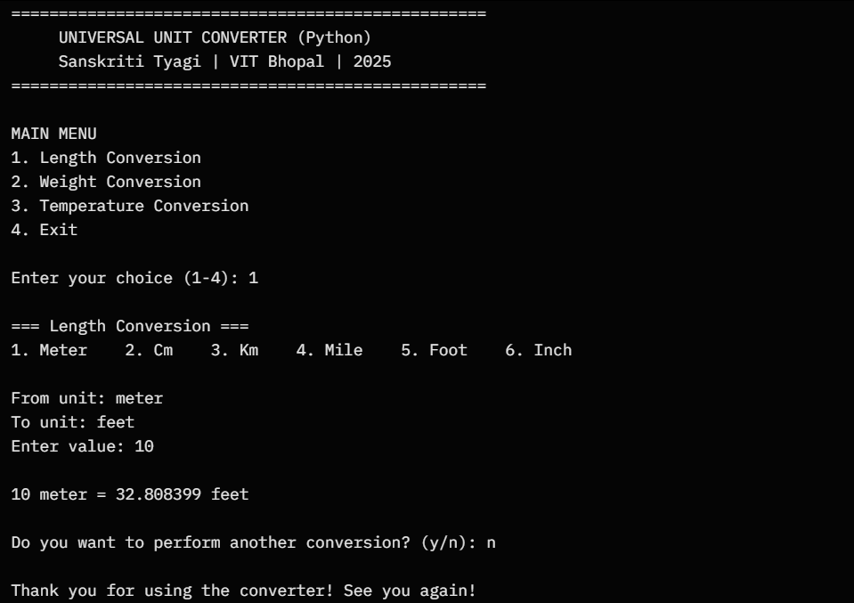

CODE:
def kg_to_gram(kg):
return kg * 1000

def km_to_meter(km):
return km * 1000

def c_to_f(c):
return (c * 9/5) + 32

while True:
print("\n1. KG to Gram")
print("2. KM to Meter")
print("3. Celsius to Fahrenheit")
print("4. Exit")

choice = input("Enter choice: ")

if choice == "1":
kg = float(input("Enter kg: "))
print("In grams:", kg_to_gram(kg))

elif choice == "2":
km = float(input("Enter km: "))
print("In meters:", km_to_meter(km))

elif choice == "3":
c = float(input("Enter °C: "))
print("In °F:", c_to_f(c))

elif choice == "4":
break

else:
print("Invalid choice")

Testing Approach:-
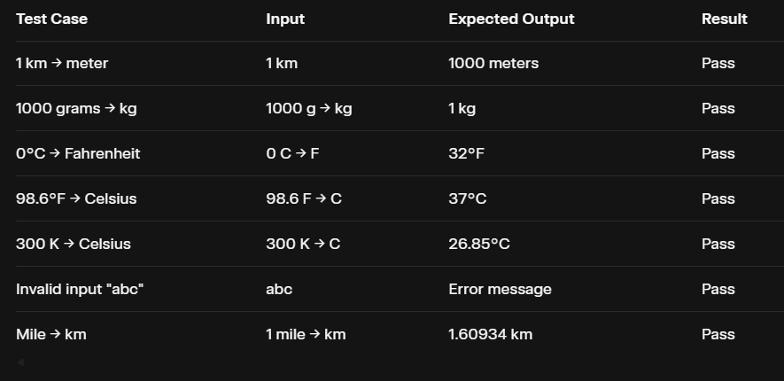

Challenges Faced: -
• Handling invalid inputs gracefully
• Designing accurate conversion formulas
• Ensuring modularity for new units
• Building clear menu structures for user navigation

LEARNINGS & KEY TAKEAWAYS
- Improved Python fundamentals
- Better understanding of modular code
- Real-world application of conversions

FUTURE ENHANCEMENTS
- Add GUI
- Add more unit categories
- Add voice input/output
- Convert to mobile app

REFERENCES
- Python Documentation
- GeeksforGeeks Tutorials
- Measurement Standards Source
.

